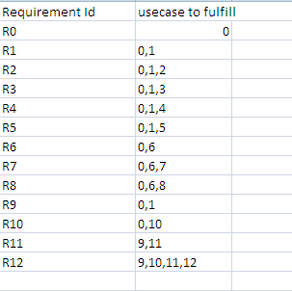

Requirement Id Function

R0 file encrypt and upload

R1 type of lock

R2 password

R3 geo-lock

R4 network lock

R5 none

R6 managing file

R7 delete file

R8 change lock

R9 generate key

R10 stores files uploaded

R11 access key validation

R12 download file